CRAVITA TECHNOLOGY

- Bug ID: BG_ID_001

- Module Name: CARRER

- Description – To verify That by clicking on Apply button registration form should get displayed.

- Steps :- 1.Go Throw cravita technology link.
https://cravitaindia.com/career.html
2.click on apply button.

- Expected result – Registration form should get displayed on screen.
Fortune Cloud

- Actual result – registration is not displaying "pravicy error " message is displaying.

- Severity - Critical

- Priority – High

- Environment: Platform:|Browser:-Chrome & Version:-142.0: |Device: Windows

- Feature name : Carrer >>Apply button

- Assigned To: Developer/Team responsible.

- Reported By: Pruthviraj Pawar

- Date Reported:

- Screenshots / Video Evidence: Attach clear screenshots or screen recordings.


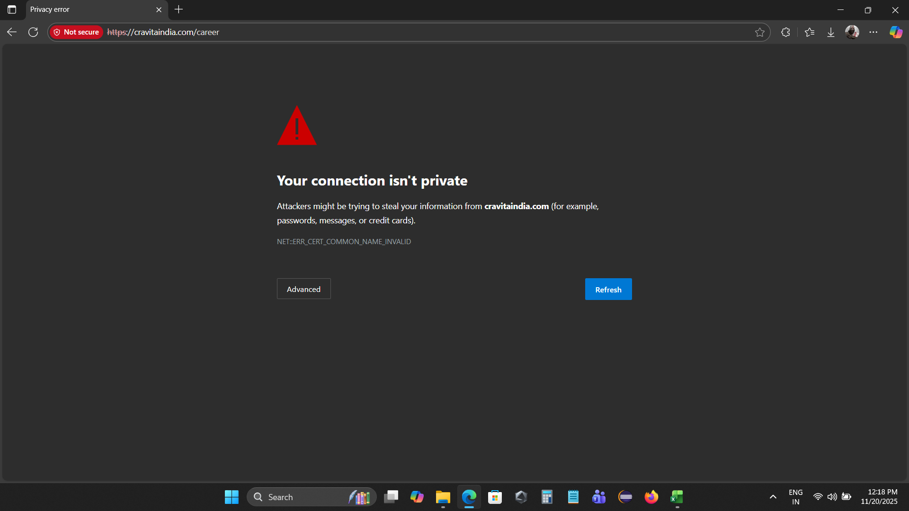

CRAVITA TECHNOLOGY

- Bug ID: BG_ID_003
- Module Name: CARRER

- Description – To verify That by "your name" field should accept only alphbetic characterstics.

- Steps :-

1.Go Throw cravita technology link.
https://cravitaindia.com/career.html
2.click on apply button.
3.fill the test data in it.
4.click on submit

- Expected result – name 1 data should be accepted and name 2 data should not be accepted.
Fortune Cloud

- Actual result – both data name1 and name2 data is accepting by your name field.

- Severity - low

- Priority – Medium

- Environment: Platform:|Browser:-Edgebrowser & Version:-142.0: |Device: Windows

- Feature name : Carrer >>Apply button>>name

- Assigned To: Developer/Team responsible.

- Reported By: Pruthviraj Pawar

- Date Reported:

Screenshots / Video Evidence: Attach clear screenshots or screen recordings.

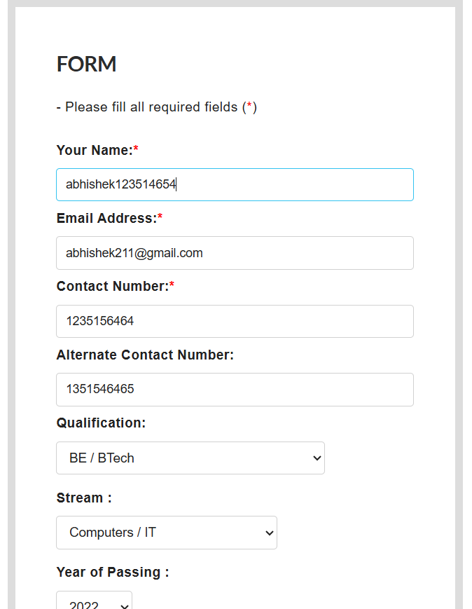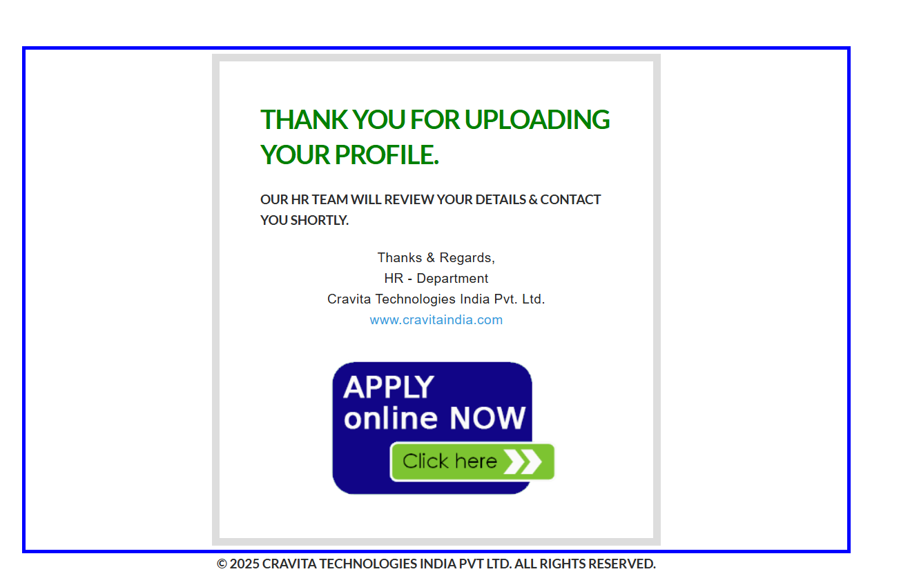

CRAVITA TECHNOLOGY

- Bug ID: BG_ID_005
- Module Name: CARRER

- Description – To verify That by "contact number field" should accept only numeric charactersters

- Steps :-

1.Go Throw cravita technology link.
https://cravitaindia.com/career.html
2.click on apply button.
3.fill the test data in it.
4.click on submit
- Expected result – contact number field should not accpet the alphabetic charater.Pop up should apper plaease enter valid details".
Fortune Cloud

- Actual result – data I s accepting by contact number field.

- Severity - medium

- Priority – medium

- Environment: Platform:|Browser:-Edgebrowser & Version:-142.0: |Device: Windows

- Feature name : Carrer >>Apply button>>contact

- Assigned To: Developer/Team responsible.

- Reported By: Pruthviraj Pawar

- Date Reported:

Screenshots / Video Evidence: Attach clear screenshots or screen recordings.
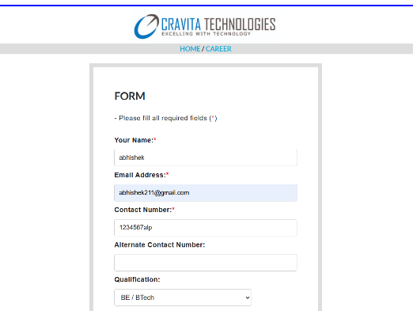

CRAVITA TECHNOLOGY

- Bug ID: BG_ID_007
- Module Name: CARRER

- Description – To verify That by email field should not accept characters after .com

- Steps :-
1.Go Throw cravita technology link.
https://cravitaindia.com/career.html
2.click on apply button.
3.fill the test data in it.
4.click on submit

- Expected result – Email field should not accept the characters after .com
Fortune Cloud

- Actual result – character are accpting after .com

- Severity - low

- Priority – medium

- Environment: Platform:|Browser:-Edgebrowser & Version:-142.0: |Device: Windows

- Feature name : Carrer >>Apply button>>Email

- Assigned To: Developer/Team responsible.

- Reported By: Pruthviraj Pawar

- Date Reported:

Screenshots / Video Evidence: Attach clear screenshots or screen recordings.

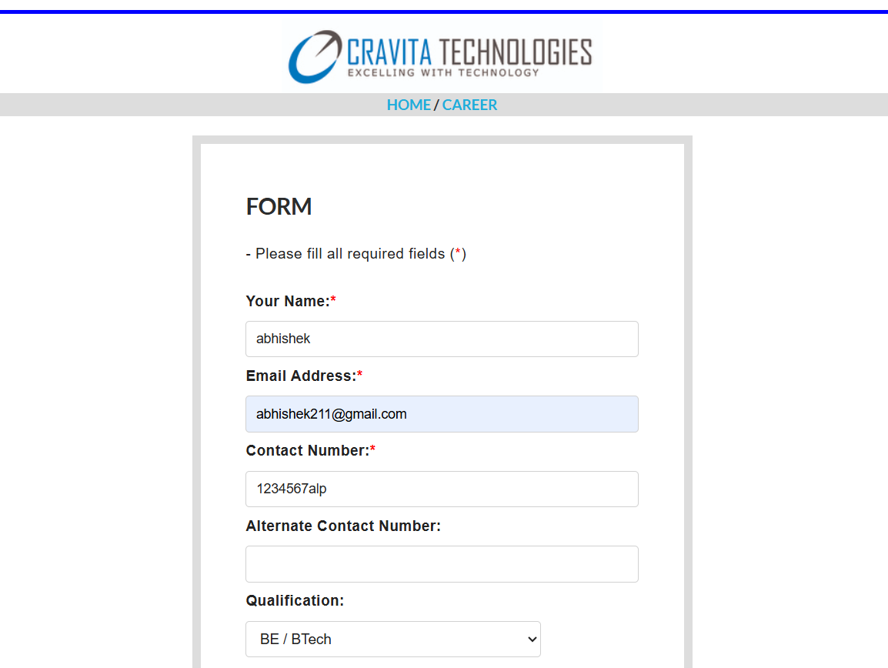
CRAVITA TECHNOLOGY

- Bug ID: BG_ID_009
- Module Name: CONTACT_US

- Description – To verify That the your name field should accept alphanumeric characters.
- Steps :-
1.Go Throw cravita technology link.
https://cravitaindia.com/career.html
2.click on contact_us.
3.Fill your data.

- Expected result – data should not be accepted by your name field containg a numeric characters, error message should apper.
Fortune Cloud

- Actual result – data is accepting by your name field.

- Severity - Medium

- Priority – medium

- Environment: Platform:|Browser:-Edgebrowser & Version:-142.0: |Device: Windows

- Feature name : CONTACT_US>>YOUR NAME

- Assigned To: Developer/Team responsible.

- Reported By: Pruthviraj Pawar

- Date Reported:

Screenshots / Video Evidence: Attach clear screenshots or screen recordings.

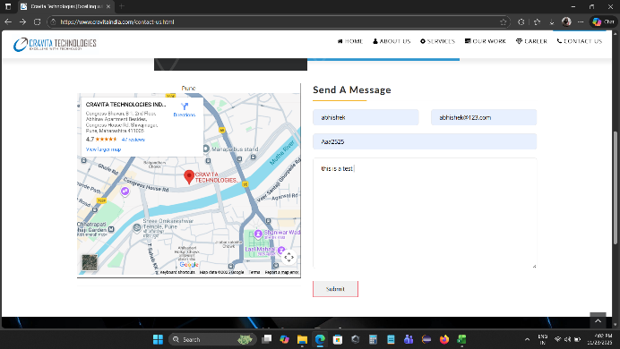

CRAVITA TECHNOLOGY

- Bug ID: BG_ID_011
- Module Name: CONTACT_US

- Description – To verify That by clicking on submit button it should show
Submitted successfully.
- Steps :-
1.Go Throw cravita technology link.
https://cravitaindia.com/career.html
2.click on apply button.
3.fill the test data in it.
4.click on submit

- Expected result – data is successfully submitted message should apper
Fortune Cloud

- Actual result – no message is appering.

- Severity - MEDIUM

- Priority – HIGH

- Environment: Platform:|Browser:-Edgebrowser & Version:-142.0: |Device: Windows

- Feature name : CONTACT_US>>SUBMIT BUTTON

- Assigned To: Developer/Team responsible.

- Reported By: Pruthviraj Pawar

- Date Reported:

Screenshots / Video Evidence: Attach clear screenshots or screen recordings.

